Time: 60 minutes
Directions: Each of the 30 multiple-choice questions is followed by five possible answer choices. Choices A through D will provide answers, while Choice E is for none of the above. Scoring will be as follows: 5 points for a correct answer, 0 for a wrong answer, and 1 for a blank answer (for a maximum possible score of 150). Figures are not necessarily drawn to scale. Do not choose incomplete answers: if a question has more than one solution, do not select a choice that only provides one of the solutions! Figures provided are not necessarily drawn to scale.
Calculators are not permitted.

As the battle between the X-men and the Brotherhood of Evil Mutants reaches a climax, the demand for crusaders against evil has heightened. Because of your sharp mathematical skills, you have been selected out of the many non-mutants to join forces with the X-men.

1. Before officially accepted as part of the X-men, you are given an aptitude test to assess your abilities. One of the questions includes:
Point D is on side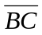, such that 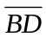 is 2 and 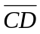 is 4. AB is 8 and AC is 10. What is AD?
A) 3 B) 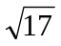 C) 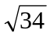 D) 2 E) NOTA
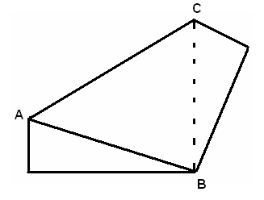
2. You finish early, so, feeling bored, you fold your test, an 8x11 rectangular sheet of paper, so that one corner touches the opposite corner, as shown. What is the area of?
A) 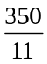 B) 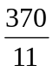 C) 370
D) Cannot be determined E) NOTA
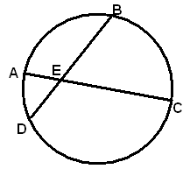

You are given a badge of the “X symbol”, a circle with two intersecting chords, as shown on the left. Use the given figure for questions 3 and 4.

3. Line segments AB and CD are extended until they meet at a point F, external to the circle. Given that DE = 6, EC = 18, BE = 9 and CD = 15, what is DF?
A) 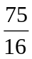 B) 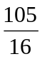 C) 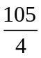 D) 105 E) NOTA

4. What is the value of sixteen times BF?
A) B) 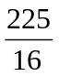 C) 105 D) 225 E) NOTA

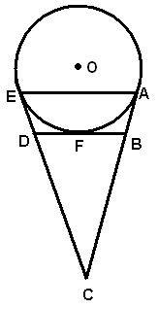
After receiving your badge, you are flown to the X-men headquarters. Feeling famished, you beeline to the kitchen, where you find Iceman eating a mint chocolate chip ice cream cone. His cone, from the side, looks like a circle O overlapping an isosceles triangle. Use the given figure for questions 5 and 6.

5. If m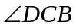= 50°, then what is the sum of m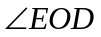 and m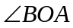?
A) 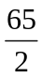 B) 50 C) 65
D) 13 E) NOTA

6. Given that CF = 8, DB = 4, EA = 6, what is the volume of the cone?
A) 18 B) 72 C) 36 D) 108 E) NOTA

7. The security alarm goes off! Because it is an outdated version, it cannot tell you the actual coordinates of the intruder. You are given that the intruder is 25 units away from the security center. Assuming that the intruder is only at a point with integral coordinates, how many possible locations can the intruder be?
A) 4 B) 8 C) 12 D) 20 E) NOTA
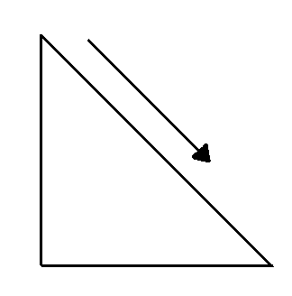
8. Professor Xavier rushed from his office to see who the intruders are. His wheel chair has wheels with a radius of 5. His wheelchair ramp has a base of 20 feet long and is 21 feet high, how many revolutions does his wheel chair make?
A) 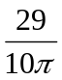 B) 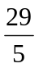 C) 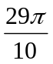 D) 29 E) NOTA
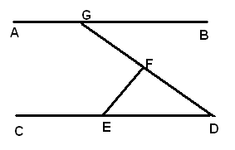
9. The intruders are the Brotherhood. One of them is Pyro, who has the abilities to create fire. At point F, he shoots a flame at the ceiling at point G. Assuming that the ceiling and the floor (lines AB and CD) are parallel, m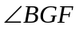= 25°, and m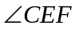= 110°, what type of triangle is DEF?
A) Right B) Obtuse C) Acute
D) Cannot be determined E) NOTA

10. Colossus, with his superhuman strength, rushes in and picks up a flat triangular piece of debris to throw at Pyro. If the debris has coordinates (3, 6); (8, 1); (13, 8), then where is its center of gravity?
A) (0, 0) B) (8, -5) C) (8, 5) D) (7, 4) E) NOTA

11. What is the area of the triangle in question 10?
A) 30 B) 48 C) 60 D) 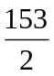 E) NOTA
12. Cyclops tries to help and shoots a laser from his eyes at an angle of elevation of 27°. Unfortunately, he misses, it reflects from the wall, and then reflects onto the ceiling and bounces back down. What is the measure of the obtuse angle that the laser makes with the floor?
A) 27° B) 63° C) 126 D) 153° E) NOTA

13. Wolverine is fighting with Sabertooth. Sabertooth claws at Wolverine, slicing off one of his horned ears. If his horned ear is in the shape of a regular tetrahedron with a side length of 6, find its volume.
A) 9 B) 18 C) 36 D) 216 E) NOTA

14. A 55-ft tall Sentinel is chasing after Jean Grey, who is 5.5 ft tall. If the Sentinel’s shadow is 80 ft long, then how far is the Sentinel from Jean?
A) 8 B) 16 C) 36 D) 72 E) NOTA

15. You and the X-men successfully defeated everyone in the Brotherhood except for its leader, Magneto. He escapes the X-men headquarters with a 25-ft ladder. The top of the ladder is resting against a vertical wall, x feet from the ground and the base is on the ground, y feet from the wall. If the top of the ladder slid down 9 feet, the base slid 13 feet, and 23x + 26y = 254, what is y?
A) 7 B) 15 C) 24 D) 27 E) NOTA

16. Magneto has escaped to the Brotherhood headquarters, so the X-men split up to search for him. Some leave the headquarters by helicopter. The landing base is an equilateral triangle with side length 50 meters. The helicopter is rising vertically from the center of the base and at one point, is 40 meters high. How far is the helicopter from each of the points of the base?
A) 20 B) 40 C) 80 D) 80 E) NOTA

17. The X-men take two jets. One leaves the base 20° south of east at 120 mph. The other leaves base 50° east of north at 180 mph. After 30 minutes of flying, how far apart are the two jets?
A) 30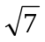 B) 90 C) 6300 D) 2100 E) NOTA

18. You and Shadow-cat look for the Brotherhood headquarters together by foot. There are seven possible locations it could be, and all seven points are concurrent with a triangle. If you and Shadow-cat want to search each of the seven locations without retracing your steps, which of the following paths should you choose?
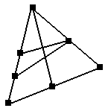
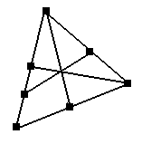
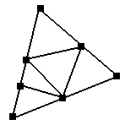
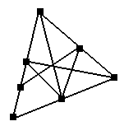
A) B) C) D) E) NOTA

19. While Storm is flying west at 60 mph, she spots the Beast at an angle of depression of 30° running east at an unknown speed. 30 minutes later, she looks behind her and sees the Beast at an angle of depression of 60°. The Beast and Storm are now 20 miles apart from each other. How fast was the Beast running?
A) 5 B) 10 C) 15 D) 20 E) NOTA

After searching everywhere, you have finally found the Brotherhood headquarters! From the side, the building looks like a stack of squares, as shown. Use the given figure below for questions 20 and 21.
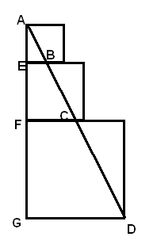
20. If FG = AF = 50, AE = 20, then what is BC?
A) 10 B) 15 C) 25 D) 50 E) NOTA

21. What is the area of quadrilateral FCDG?
A) 625 B) 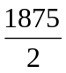 C) 1875 D) 3750 E) NOTA
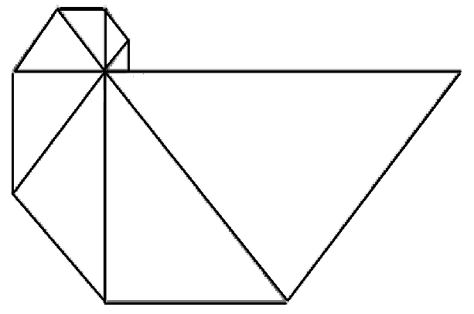
22. Once inside the Brotherhood headquarters, you and the X-men must climb down a set of spiraling stairs, which, from above, looks like a series of isosceles right triangles. If the leg of the largest triangle in the figure below has length 64, then what is the length of the hypotenuse of the smallest triangle shown?
A) 2 B) 2 C) 4 D) 8 E) NOTA

23. What is the perimeter of the figure in question 18?
A) 60 B) 60 + 60 C) 120 + 124 D) 120 + 120 E) NOTA

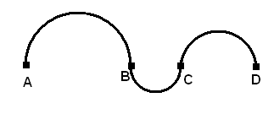
24. You and the X-men run down a curvy hallway, in the shape of three alternating semi-circles, shown by the provided figure. The first, second and third semicircles have radii in the ratio 3:1:2. The whole hallway has length 12. What is the area of an isosceles right triangle with hypotenuse length of AD?
A) 2 B) 9 C) 36 D) 72 E) NOTA

25. The X-men encounter four doors. Each one has a mathematical statement about right triangles. One out of the four statements is true and will lead to the Evil Forces while the other three are false and lead to traps. Which door should they choose?
A) B) C) D)
The smaller leg of a Pythagorean Triple of Plato is always even
A 7-24-25 right triangle is an example of a Pythagorean Triple of Plato
An 8-15-17 right triangle is an example of a Pythagorean triple of Pythagoras

The hypotenuse of a primitive Pythagorean Triple is sometimes odd

E) NOTA
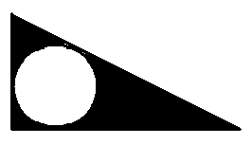
26. The X-men then find a room with a triangular shaped floor. Its sides have length 8, 15, 17. If they step in the black area, a trap will go off. Night-crawler is used to teleport onto the white inscribed circle, which has a switch to turn off the trap. What is the probability that he will teleport successfully and land on the white circle?
A) 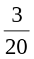 B) 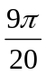 C) 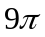 D) 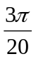 E) NOTA

27. The X-men proceed through the room and find Magneto alone in the next room. You, Cyclops and Jean Grey stand around Magneto so that Magneto is equidistant from all three of you. What is the special name for this point?
A) incenter B) circumcenter C) centroid D) orthocenter E) NOTA

28. Jean Grey tries to read Magneto’s mind. He is thinking of the minimum number of triangles that have the following properties: acute, obtuse, right, scalene, equilateral, and isosceles. How many triangles is Magneto thinking of?
A) 3 B) 4 C) 5 D) 6 E) NOTA

29. After noticing how outnumbered he was, he exclaims, “I will surrender as long as you answer this question correctly: A triangle with side lengths 28, 45, and 53 is inscribed in a circle with radius r. What is the value of 2r -6?”
A) 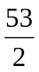 B) 47 C) 50 D) 53 E) NOTA

30. Assuming you answered correctly, you and the X-men go out to eat pizza to celebrate the victory. They want to cut a flat, circular pizza into n congruent pieces using diameters of the pizza. Each of the pieces is a sector with an integer number of degrees in its central angle. What is the maximum number of pieces?
A) 90 B) 180 C) 360 D) E) NOTA

